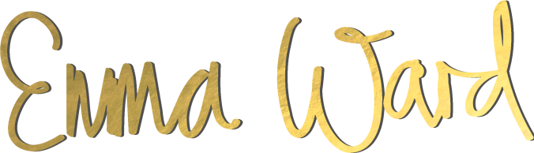
Name:
Phone:
Email
Address:
Website:
Age:
Profession:
Relationship Status:
Children and ages:

- What are your reasons for wanting to receive coaching?

- What is your current profession or business? If in business, how long have you been in business? What is the current status of your business?

- If you’d like to start a business, what sort of business would you like to develop?

- If in business, what’s your vision?

- Do you want to develop products or services or both?

- What are the strengths and weaknesses of your business (or business idea)?

- Who is your target market or who do you want to serve?

- What is your target market’s biggest frustration or concern?

- What are your specific goals for this coaching programme and for taking your life and business to the next level?

- What specifically do you want to accomplish before the end of this programme?

- What has kept you from accomplishing these goals in the past?

- Describe your relationship with your mother.

- Describe your relationship with your father.

- Describe your family’s blueprint around money - thoughts, beliefs, habits, and mentality around it.

- What’s your money story?

- What’s your ideal annual income?

- What other personal and business development work have you done?

- Please list all programs, seminars, teachers, mentors, healers, books etc. that have been
- part of your development. And which were the most useful to you?

- How committed are you to achieving your stated goals? How many hours per week?

- What are you willing to change about yourself or your business to accomplish your goals?

- What are you most proud of in your life/career/business so far?

- If you could change three things about your life or business, what would they be?

- What is going to be the most difficult part, or the biggest obstacle to success for you?

- What will you need to overcome?

- What are your strengths and weaknesses? Be specific.

- What’s your intention or non-negotiable goal for this course?

- What specifically do you want from me as your coach throughout this process?

- Do you have any other comments or questions for me before we begin?

